Chapter 5 Review Quiz

Instructions:
Do not submit this document. You will be answering these questions on our course Mastering Geology page. Use this document to mark your answers for quick reference.

1) Mount St. Helens is ________.
A) a basaltic cinder cone
B) an explosive stratovolcano
C) a basaltic shield volcano
D) a small, welded tuff cone

2) Which of the following would you most expect to accompany an eruption of Kilauea Volcano?
A) mudflows
B) explosions of ash and debris
C) a cloud of hot gas and ashes
D) fluid lava flows

3) Which one of the following shows the correct order (left to right) of decreasing magma viscosity?
A) rhyolite, andesite, basalt
B) andesite, rhyolite, basalt
C) basalt, rhyolite, andesite
D) basalt, andesite, rhyolite

4) The more ________ in a magma, the more its viscosity increases.
A) silica
B) ferromagnesian minerals
C) air bubbles
D) water

5) Why do magmas rise toward Earth's surface?
A) Magmas are more viscous than solid rocks in the crust and upper mantle.
B) Most magmas are richer in silica than most crustal and upper mantle rocks.
C) Magmas are mainly liquid and contain dissolved fluids such as water; most are less dense than the adjacent solid rock.
D) all of the above

6) Which of the following magma types has the highest gas content?
A) basaltic magma
B) andesitic magma
C) rhyolitic magma
D) All of these magmas have equal gas content by weight.

7) ________ are usually the most abundant gases typically released during volcanism.
A) Chlorine and sodium
B) Neon and ammonia
C) Oxygen and nitrogen
D) Water vapor and carbon dioxide

8) Kilauea and Mauna Loa are ________.
A) explosive, rhyolitic volcanoes
B) andesitic stratovolcanoes
C) basaltic shield volcanoes
D) small, basaltic cinder cones

9) Which kind of eruptive activity is most likely to be highly explosive?
A) lava flows from a large shield volcano on an oceanic island
B) fissure eruptions feeding lava to flood basalt accumulations
C) eruptions of big, continental margin, composite cones or stratovolcanoes
D) lava flows from a large cinder cone complex

10) Large, volcanic depressions formed by subsidence and collapse are known as ________.
A) lahars
B) craters
C) calderas
D) fissures

11) Which region has the greatest concentration of currently active volcanoes?
A) the coastal plain of western Africa
B) European Russia and Siberia
C) the area surrounding the Red Sea
D) the circum-Pacific area

12) The (geologically) recent volcanic activity in Yellowstone National Park is ________.
A) related to plate subduction
B) related to a divergent plate boundary
C) related to a transform plate boundary
D) related to intraplate, hot spot volcanism

13) Which one of the following best describes volcanism in the Cascade Range, northwestern United States?
A) related to a mantle hot spot
B) related to plate subduction
C) related to a mid-oceanic ridge system
D) related to deep, transform faults

Critical thinking and discussion questions. Use complete sentences, correct spelling, and the information presented in chapter 5 to answer the questions below.

14) What type of volcano is shown in the diagram below?

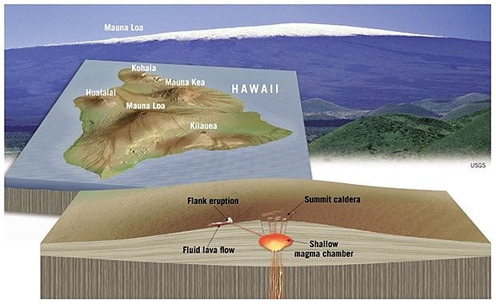

A) Shield volcano
B) Composite volcano
C) Cinder cone

15) What type of volcano is shown in the diagram below?

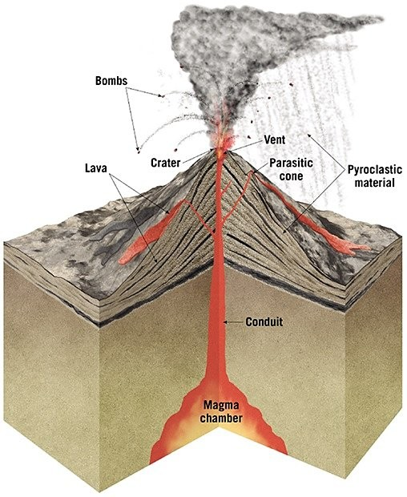

A) Shield volcano
B) Composite volcano
C) Cinder cone

